**8.3.1**

Hey, Aanya. **Can you help me with this work?**

I’m sorry Khae. **I can’t help you now**...Yes. **I can hear you**. Can you come back this afternoon? **I can help you**

Thank you Aanya.

Come in! Hi Khae.

Hi Marco

**Can you close the door?**

**Yes, I can**. What’s that?

Football. **I can’t watch it on TV but I can watch it on my computer**

Oh

My brother and sister are athlete match in Italy

**I’m sorry you can be there**

Great

Excuse me, Marco. Can you help me what this work?

What is it?

It’s a new design. Todd say it wrong

**Can you fix it?**

**I can’t fix it**. Can you help me which this work?

I’m not a designer. **I can’t help you**. I’m sorry

It’s okay.

Khae. Can you close the door?

Yes

I can bring you a pen and paper

Excuse me, can you help me fix this TV?

Gareth can speak Chinese

Julia says she can’t come back tomorrow

He can play football well. He plays a lot

They can’t see the TV. It’s very small!

Can you come back this afternoon? I can help you then

What does Khae want?

* Khae wants help with her work

Aanya doesn’t help Khae now. Why?

* She is on the phone

Khae needs help with her design

Marco doesn’t help Khae. Why?

* He isn’t a designer

I can’t help you right now = I can’t help you now

The Big Boss says you can’t watch TV at work!

Marco, It that’s football on your computer?

Yes. It is! Computers are great! I watch the football in my office

No, you can’t. The Big Boss says you can’t watch TV at work!

It’s not a TV. It’s a computer

OK. Then you can watch TV on your computer

Then I can’t watch this football game

That’s right. You can’t

Can I go home and watch it at home?

No, you can. It’s time for work

OK. But I can’t work. I want to watch the game

Then you can ask the Big Boss. He likes work, he doesn’t like football

Ask the Big Boss? No, thank you I want to ask him about football at work

Anne can’t speak Chinese

My name is Jim. I love languages! I am from New York, but I speak English, French, and Chinese. My roommates speak many languages, too. Jiaqui is from China, and he can speak Chinese. Anne is from France, so she speaks French. But Anne does not speak Chinese, and Jiaqui does not speak French – we all talk to each other in English.

* Jiaqui can’t speak French
* Jim can speak three languages
* Anne can speak French and English only
* Jiaqui can’t talk to Jim in French
* Anne can’t talk to Jiaqui in French
* Jim can talk to Anne in English

**8.3.2**

Dear Khae,

I need your design today.Can you give it to me this afternoon?

Todd

Dear Todd,

I can't finish the design. I'm sorry

Khae

Dear Khae,

I can help you now. See you soon

Anna

I need my laptop and phone. And coffee for Anna.

First, Khae reads something from Todd

What does Todd want?

--> Khae's design

Khae tells Todd: She can't finish the design

Khae needs coffee. Why?

--> Aanya can help her

Dear Sofi,

I know you’re not sick. We need bread for chicken sandwiches.

Can you come to the restaurant and make bread?

Thank you,

Nadi

Wow, you have many letters, read them to me

Ok. First one. "Dear Sofi, Are you sick?"

Ands?

"There are many customers at work today. Se you soon, Diego"

Read more

This is from Shen. "Dear Sofi, can you make me a sandwich?"

What does he say next?

"I'm hungry and you're a good cook. Thanks,Shen"

Read one more

OK, OK. This is from Khae

What does she say?

"Hi Sofi, Aanya says she can help me!"

It's that a last one?

No. There's more. "I need coffee for Aany! Talk to you soon, Khae"

Dear John,

I need your help.

Can you direct my movie?

Shen

Hi Benny,

I need the camera.

Can you give it to me tonight?

Shen

Hello Khae,

I can't fix your laptop

I'm sorry

Shen

Hi Mrs.Berry

I can help you tomorrow

See you soon!

Sofi

Dear Aanya, You can come help? Great!

See you soon

Thanks,

Khae

3.

Hi, Aanya

**I’m on the phone with my brothers and sisters**. wait minute.!...Okay. Love you...Bye!. Sorry, **my mother and father call me at work**. T**hen I talk to my brothers and sisters, too**

Woa

**Put your laptop and phone here**

Here’s your coffee and milk

Thank you. Does it has sugar? **I like milk and sugar in my coffee**

**Oh. I’m sorry. Yes. The coffee has milk and sugar**

Thanks

**Thank you for your time and help**, Aanya

Your’re wellcome

Okay. Here’s the design

**Can you give me that pen and paper?**

Here is that pen and paper

Thanks. Time to draw a new design

Can we fix it?

Yes. We can

It’s good. I can give it to Todd. Thank you for your help, Aanya

Your’re wellcome Khae

You can delete you email to Todd

You right

Who is Aanya on the phone with?

* Her family

What does Khae give to Aanya?

* Coffee

Aanya is helping khae create a new design

Why does Aanya say, “You can delete your email to Todd?

* Because now Aanya can give the new design to Todd

Here is some milk and sugar

She has two brothers and a sister

What is your name and address?

I’d like coffee, water and a sandwich please

I want a chicken sandwich and French fries, too.

We need glasses and plates for dinner

Sofi makes bred and soup for lunch

They like books and movies

The paper and pens are for new employees

Do you play tennis and criket?

Hi, wellcome to our restaurant. How are you today?

I hungry. How are you?

I good. Do you have questions about menu?

No questions. Can I order?

Yes, What can I bring you?

Can I have a chicken sandwich and French fries?

I’m sorry. We don’t have any French fries

No French fries! Can I have soup?

Sure. Soup and the chicken sandwich. Do you want something to drink?

Yes. I like water and coffee

Water and coffee. Got it!

One more thing: I’d some cake, too

Yes. Okay, that soup, a chicken sandwich, coffee, juice and cake

No! I want water and coffee

Ah. Okay, water and coffee

Yes, water and coffee. Thank you

I'd like pasta with white sauce.

I'd like to order a sandwich and French fries.

I want pizza for dinner.

She has three brothers and two sisters

In my bag, there are keys and and a phone.

On my desk, there are books and a computer.

Can you fix it?

Can Khae close the door? Yes, she can.

Can I order soup and bread?

I'm in the car with my brother and sister.

Aanya, can you fix it?

Khae can't finish the design.

I can watch it on my computer.

Benny, can you play tennies with me today?

I don't speak French, but I can speak German. German is easy for me.

Khae understands Thai. And she can speak English.

Can Khea close the door?

=> Yes, she can.

Can Aanya help Khae?

* No , she can’t help now.

Marco can watch football on his television.

Can Khae finish the design?

* No, she can’t.

I’m not a designer.

* I can’t draw well.

I’m a good engineer.

* I can build new products at the Company Company.

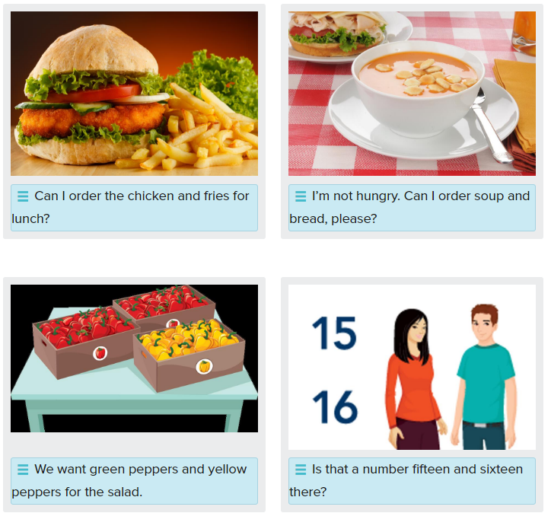

Here’s your coffee and milk.

Thank you for your time and help. See you soon.

